Ramolatela Lebaea

**Program That Will Accept**

**A Text File**

**From**

**A PC Over USART**

**And**

**Return an Updated Version**

The objectives of this project are to send files via USART to a PC, write a program that accepts a text file from a PC over USART and returns an updated version, use an LCD screen to show status messages during the process, build a circuit using resistors, push buttons, Arduino, and an LCD, use push buttons to start processes like sending files and editing text, and gain more knowledge about USART and understand its relevance in modern embedded systems. USART, which stands for universal synchronous/asynchronous receiver/transmitter, is a hardware component that allows a device to communicate serially. It operates in two modes: a slower asynchronous mode, similar to a universal asynchronous receiver/transmitter (UART), and a quicker synchronous mode that uses a clock signal.

**Components**

* 1x 1602 LCD
* 1x 4X4 membrane Keypad
* 2x N.O. Push buttons
* 1x 220Ω Resistor
* 1x 50kΩ Potentiometer
* Connecting wires
* Breadboard
* Arduino Uno Rev3
* USB A to B cable for Arduino

## **Circuit Diagram**

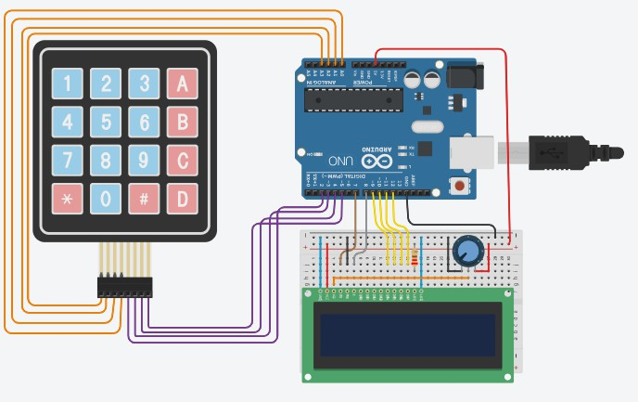

**Circuit connection Using Proteus 8**

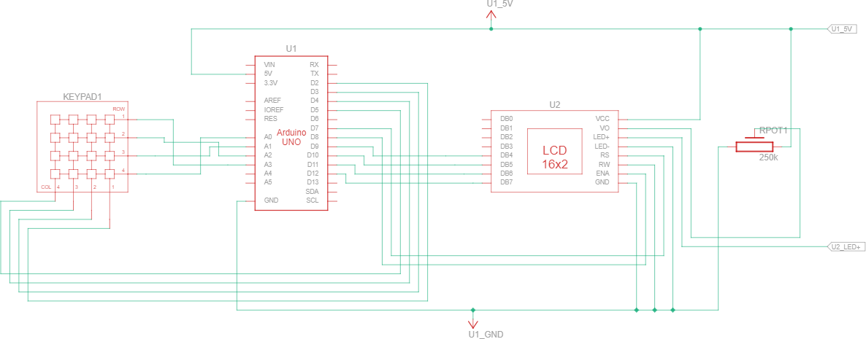

# 

# **Hard Wired Circuit**

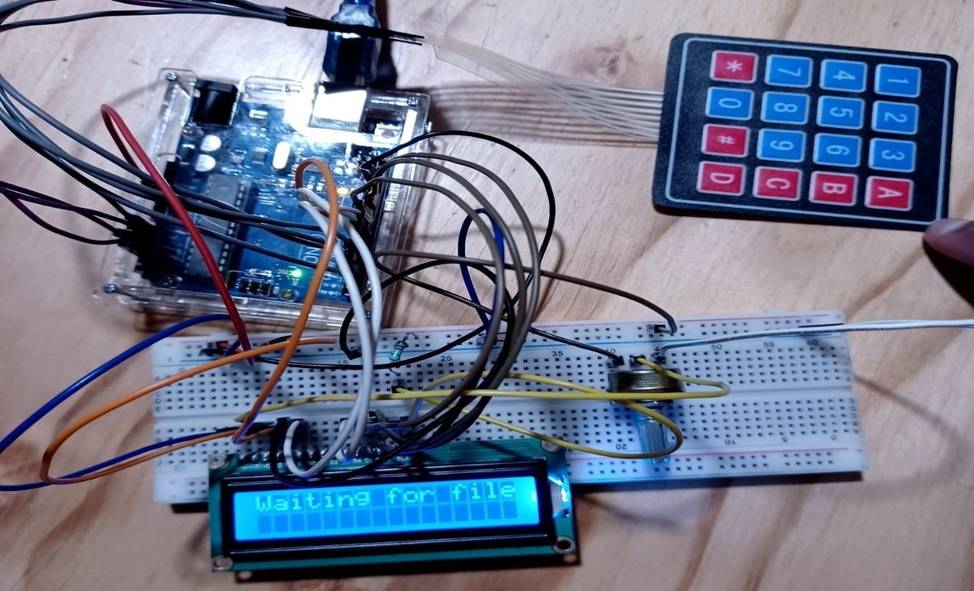

*Figure 7.1: Microcontroller Output*

* The User Will Enter His/her Information Three Times Using the Serial Monitor.

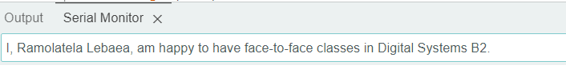

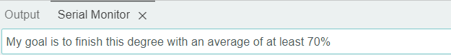

* When The File Is Received The User Will Be Asked To Press Key A Of The Keypad To Change The Text.

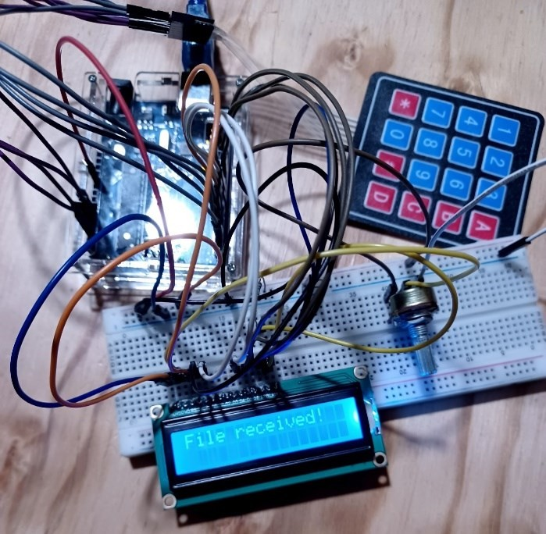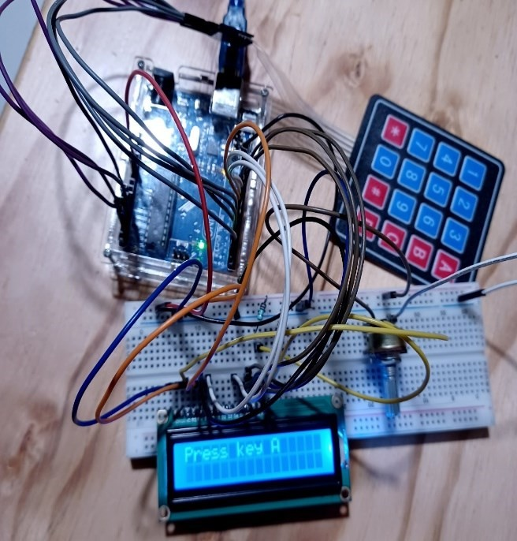

*Microcontroller LCD Output Microcontroller LCD Output*

* After It Will Show On The LCD Screen When Changing The Text And When It Is Complete.

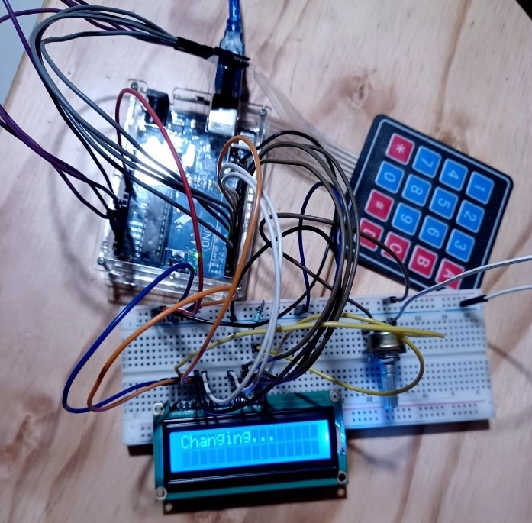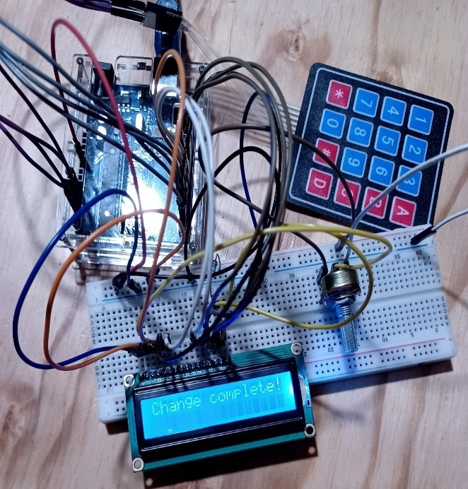

*Microcontroller LCD Output Microcontroller LCD Output*

* When The Change Is Complete, It Will Ask The User To Press Key B Of The Keypad To Display Back The Transferred Text On PC.

*Microcontroller Output Microcontroller Output*

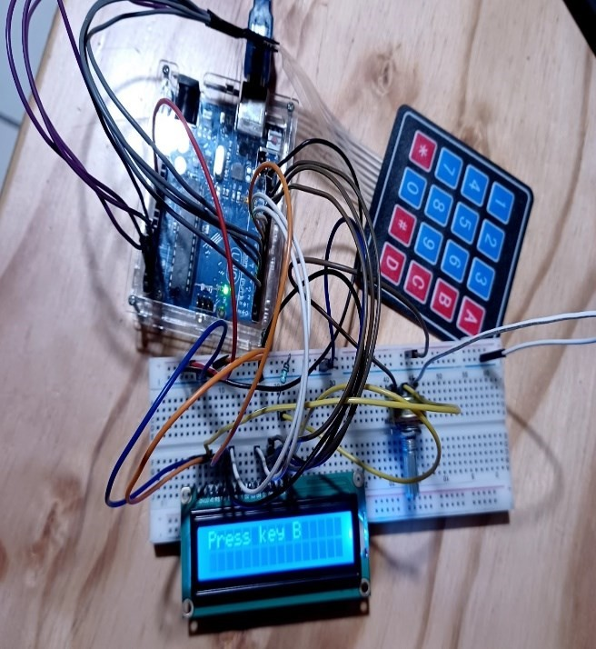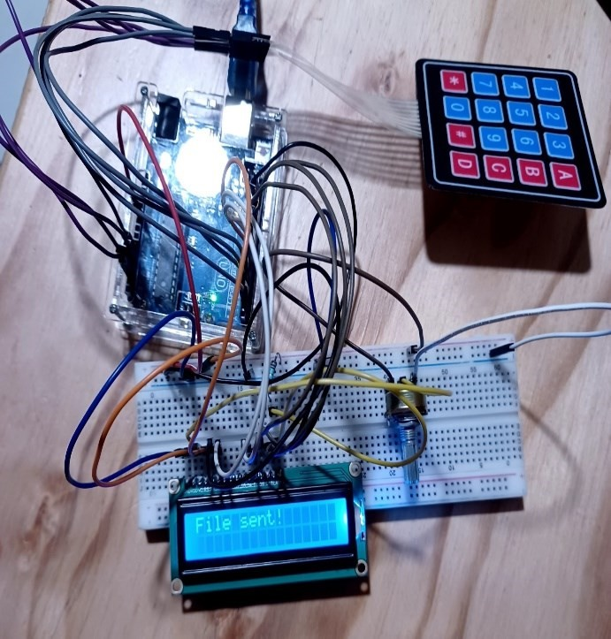

# **CIRCUIT OPERATION**

The computer will accept files from the serial monitor and starts by waiting for the user to provide text files via USART. It then asks the user to press keypad key A to begin text edits, displays

progress throughout text modification on the LCD screen, and then asks the user to press key B to return the modified file to the PC. The procedure is then repeated while waiting for the next file, thus showing communication, user

involvement, and data modification in the context of an embedded system.

**Serial Monitor Output**

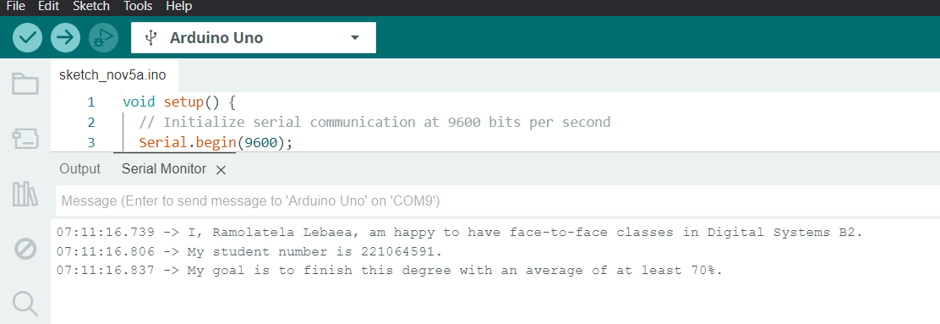

This assignment demonstrated how a PC and a microcontroller may

communicate with one another using USART. Push buttons, LCD screens, and an Arduino board were used in the assignment to show how computer elements may interact. This demonstrated how individuals may engage with machines in addition to teaching us about various technological topics. Overall, it was a practical lesson in communication and the development of technology of this kind.